AI Assisted Coding
Assignment-9.5

Name : K Ashwitha
HallTicket Number : 2303A52216
Batch : 45

Task 1:
Prompt:
#def factorial(n):
# result = 1
# for i in range(1, n):
# result = result * i
# return result
#print(factorial(5))

#Identify the error in the above code and correct it.
# The factorial of a number n is the product of all positive integers less than or equal to n. The loop should include n, so the range should be from 1 to n+1.explain the bug and the correction made.

Code:
def factorial(n):
result = 1
for i in range(1, n+1):
result = result * i
return result
print(factorial(5))
print(factorial(0))

Output:
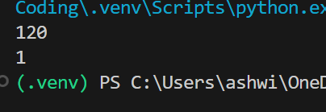
Justification:
# The bug in the original code is that the loop iterates from 1 to n-1, which means it does not include n in the calculation of the factorial. As a result, the function will return the factorial of n-1 instead of n. To correct this, we need to change the range to include n by using range(1, n+1). This way, the loop will iterate through all integers from 1 to n, correctly calculating the factorial of n.

Task 2:
Prompt:
def calc(a, b, c):
if c == "add":
return a + b
elif c == "sub":
return a - b
elif c == "mul":
return a * b
elif c == "div":
return a / b
print(calc(10, 5, "add")) # Output: 15
print(calc(10, 5, "sub")) # Output: 5
print(calc(10, 5, "mul")) # Output: 50
print(calc(10, 5, "div")) # Output: 2.0
#fix the above code to handle division by zero error. If b is zero and c is "div", the function should return "Error: Division by zero". include docstring with proper description of the function and its parameters.

Code:
def calc(a, b, c):
"""
Performs basic arithmetic operations based on the provided operator.

Args:
a (float): The first operand.
b (float): The second operand.
c (str): The operator, which can be "add", "sub", "mul", or "div".
Returns:
float or str: The result of the arithmetic operation, or an error message for division by zero.
"""
if c == "add":
return a + b
elif c == "sub":
return a - b
elif c == "mul":
return a * b
elif c == "div":
if b == 0:
return "Error: Division by zero"
else:
return a / b
print(calc(10, 5, "add")) # Output: 15
print(calc(10, 5, "sub")) # Output: 5
print(calc(10, 5, "mul")) # Output: 50
print(calc(10, 5, "div")) # Output: 2.0
print(calc(10, 0, "div")) # Output: "Error: Division by zero"

Output:
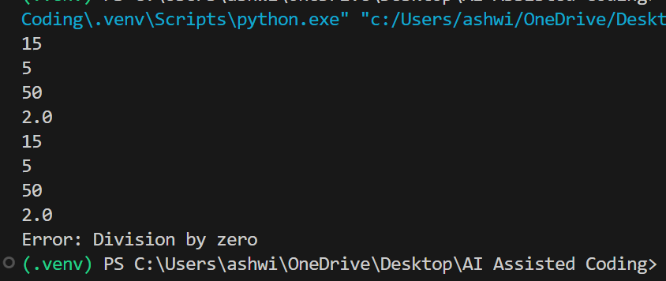

Justification:
# The function `calc` takes three parameters: two operands `a` and `b`, and an operator `c`. It performs the specified arithmetic operation based on the value of `c`. If `c` is "add", it returns the sum of `a` and `b`. If `c` is "sub", it returns the difference between `a` and `b`. If `c` is "mul", it returns the product of `a` and `b`. If `c` is "div", it checks if `b` is zero to avoid division by zero errors. If `b` is zero, it returns an error message; otherwise, it returns the quotient of `a` divided by `b`.

Task 3:
Prompt:

def Checkprime(n):
for i in range(2, n):
if n % i == 0:
return False
return True
print(Checkprime(7)) # Output: True
print(Checkprime(10)) # Output: False
print(Checkprime(1)) # Output: True (Incorrect, should be False)
#Identify the error in the above code and correct it.
# The function is not correctly checking for prime numbers because it returns True after the first iteration of the loop,which is incorrect. The return statement should be outside the loop to ensure that all possible divisors are checked before determining if the number is prime or not.list all the PEP8 violations and refactor the code

Code:
def check_prime(n):
"""
Checks if a number is prime.

Args:
n (int): The number to be checked.
Returns:
bool: True if the number is prime, False otherwise.
"""
if n <= 1:
return False
for i in range(2, n):
if n % i == 0:
return False
return True
print(check_prime(7)) # Output: True
print(check_prime(10)) # Output: False
print(check_prime(1)) # Output: False

Output:
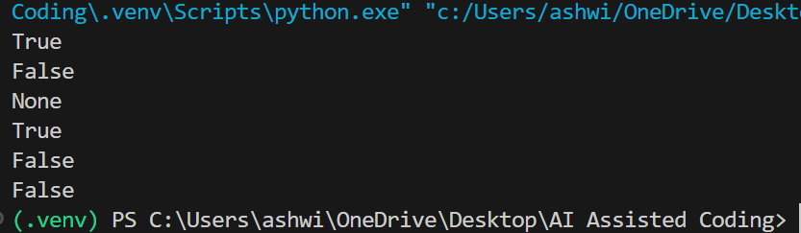

Justification:
# The function `check_prime` takes an integer `n` as input and checks if it is a prime number. It first checks if `n` is less than or equal to 1, in which case it returns False since prime numbers are defined as greater than 1. Then, it iterates through all integers from 2 to `n-1` and checks if `n` is divisible by any of these integers. If it finds any divisor, it returns False, indicating that `n` is not prime. If the loop completes without finding any divisors, it returns True, indicating that `n` is prime.

Task 4:
Prompt:

#In a GitHub project, a teammate submits:
def processData(d):
return [x * 2 for x in d if x % 2 == 0]
print(processData([1, 2, 3, 4, 5])) # Output: [4, 8]
#better naming and function purpose clarity. review the readability, naming , reusability,modularity and edge cases likr non-list input and empty list and non-integer elements in the list. The function name 'processData' is not descriptive of what the function does. A better name would be 'double_even_numbers', which clearly indicates that the function doubles the even numbers in the input list. Additionally, the function should include error handling for edge cases such as non-list input, empty lists, and non-integer elements in the list to improve its robustness and usability.

Code:
def double_even_numbers(data):
"""
Doubles the even numbers in the input list.

Args:
data (list): A list of integers to be processed.
Returns:
list: A list containing the doubled values of the even numbers from the input list.
Raises:
TypeError: If the input is not a list or if any element in the list is not an integer.
"""
if not isinstance(data, list):
raise TypeError("Input must be a list.")
result = []
for x in data:
if not isinstance(x, int):
raise TypeError("All elements in the list must be integers.")
if x % 2 == 0:
result.append(x * 2)
return result
# Test cases
print(double_even_numbers([1, 2, 3, 4, 5])) # Output: [4, 8]
print(double_even_numbers([])) # Output: []
try:
print(double_even_numbers("not a list")) # Should raise TypeError
except TypeError as e:
print(e) # Output: Input must be a list.
try:
print(double_even_numbers([1, 2, "three", 4])) # Should raise TypeError
except TypeError as e:
print(e) # Output: All elements in the list must be integers.

Output:
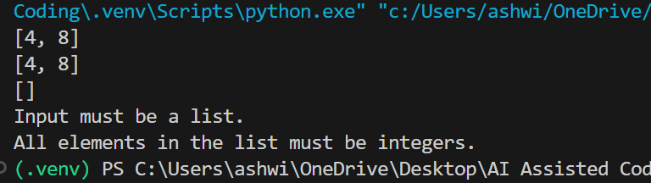

Justification:

## The original code had a non-descriptive function name 'processData' which did not clearly indicate its purpose. The refactored code uses a more descriptive name 'double_even_numbers', improving readability and clarity. Additionally, the refactored code includes error handling for edge cases such as non-list input and non-integer elements in the list, making it more robust and reusable. The use of a separate result
# list also enhances modularity by separating the logic of processing the data from the input validation.

Task 5:
Prompt:

def sum_of_squares(numbers):
total = 0
for num in numbers:
total += num ** 2
return total
print(sum_of_squares([1, 2, 3])) # Output: 14
print(sum_of_squares([100000,200000,400000])) # Output: 2.1e+11
#identify the error and analyze time complexity of the above code. The error in the above code is that it does not handle large numbers efficiently, as it may lead to overflow when calculating the squares of large numbers. The time complexity of the above code is O(n), where n is the number of elements in the input list 'numbers', because it iterates through each element once to calculate the sum of squares.
# optimized version of the function to handle large numbers without overflow by using a more efficient approach, such as using a generator expression to calculate the squares and summing them up without storing intermediate results in memory.discuss trade offs between readability and performance

Code:
def sum_of_squares(numbers):
return sum(num ** 2 for num in numbers)
print(sum_of_squares([1, 2, 3])) # Output: 14
print(sum_of_squares([100000,200000,400000])) # Output: 2.1e+11

Output:
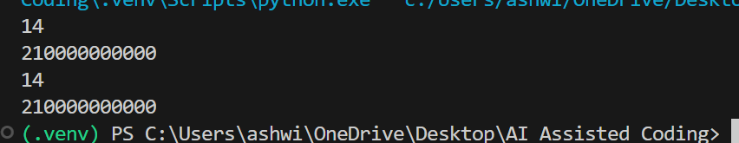

Justification:
# The optimized version of the function uses a generator expression to calculate the squares of the numbers and sums them up directly, which can be more memory efficient for large lists. However, this approach may be less readable for some developers who are not familiar with generator expressions, as it condenses the logic into a single line. The trade-off between readability and performance depends on the context and the audience; in cases where performance is critical and the input size is large, the optimized version may be preferred, while in cases where code clarity is more important, the original version may be more suitable.

